Bahria University,

Karachi Campus



LAB EXPERIMENT NO.

**02**

LIST OF TASKS

|  |  |
| --- | --- |
| TASK NO | OBJECTIVE |
| 1 | **Implement box plot and histogram for IRIS Data set** |
| 2 | **In a workflow group create an empty workflow “exercise1”**  **a. Read CSV file**  **b. Remove irrelevant columns**  **c. Enter the name and description for all nodes in the workflow**  **d. Performed basic statistics**  **e. Performed the column and row filter and finally write the data to output file.**  **f. Save and execute workflow exercise 1.** |
|  |  |
|  |  |
|  |  |

**Task 1: Implement box plot and histogram for IRIS Data set**

**Solution:**

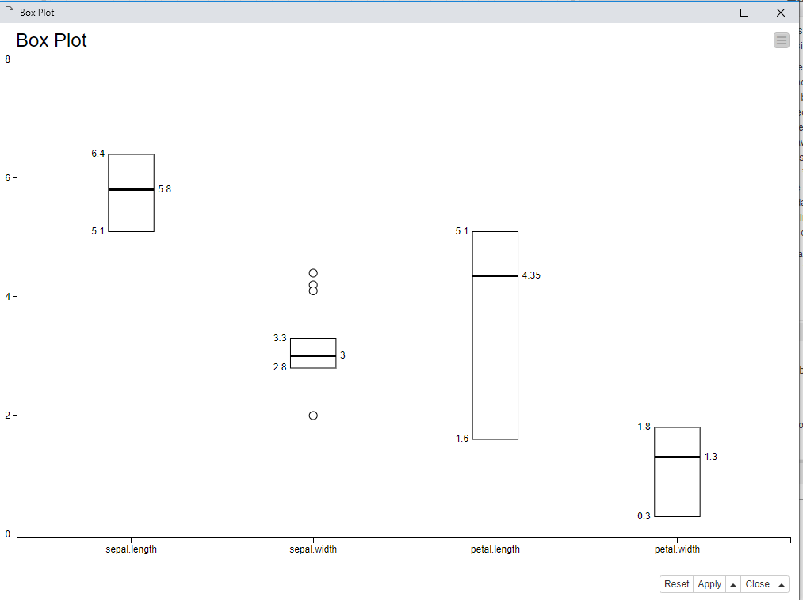

**Task 2: In a workflow group create an empty workflow “exercise1”**

1. **Read CSV file**

1. **Remove irrelevant columns**

1. **Enter the name and description for all nodes in the workflow**

**Csv reader**: File Reader that will read the csv files to execute it according to

**Box plot:** It will represent the plot depending upon the dataset and will plot a box upon the given data.

**Statistics:** statistics will perform some computation on the required dataset.

1. **Performed basic statistics**

1. **Performed the column and row filter and finally write the data to output file.**

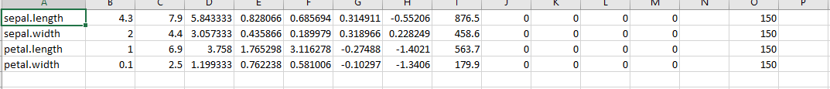

1. **Save and execute workflow exercise 1.**

